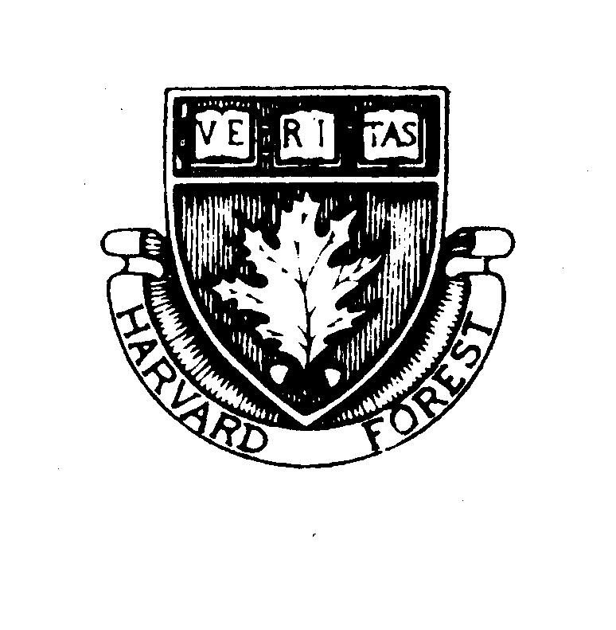

HARVARD UNIVERSITY

HARVARD FOREST

324 North Main Street
Petersham, Massachusetts
U.S.A. 01366
http://harvardforest.fas.harvard.edu/

Phone: 978-724-3302
FAX: 978-724-3595
February 11, 2014

Matthew Lau
Northern Arizona University - Department of Biological Sciences
Box 5640
Flagstaff, AZ 86011-5640
Dear Matthew,

This letter confirms your academic appointment as a postdoctoral fellow in the Harvard Forest at Harvard University beginning on May 1, 2014 through April 30, 2015.

In this capacity, you will be under the direct supervision of Dr. Aaron Ellison and will be expected to adhere to all university rules and requirements. This will be a paid, benefits-eligible position. You will receive $42,000 during the initial appointment period and will be eligible for the University’s comprehensive medical and dental benefits. Note that prior to assuming this grant funded position, you will be required to provide a letter from NAU Registrar's office confirming that you have satisfied all requirements for receiving your PhD.

Please note that you must enroll in benefits within thirty days of the start-date of your appointment. As you must first complete your I-9 form in person please contact Laurie Chiasson, the Payroll Coordinator, as soon as possible, to arrange a visit to complete the I-9. Once your completed I-9 has been processed, you will be able to enroll in benefits.

You will earn vacation time at a rate of 1.67 days per month of completed service. In accordance with FAS policies, you are required to use all accrued vacation prior to the scheduled end of your term appointment. If you should fail to use your accrued vacation days before the end of your term appointment, you will not be paid out for any unused days; in addition, in the event that your appointment is renewed or your appointment status changes, you will not be allowed to carry over any unused vacation days.

Your work with Dr. Ellison ecological modeling on the Ant Dimension and Pitcher Plant grants will be an exciting contribution to the science done at Harvard Forest. Formalities aside, we are enthusiastic about having you join our lab and are looking forward to working with you. Please contact Edythe Ellin at ellin@fas.harvard.edu if you have any questions regarding the terms of your appointment.
Sincerely, 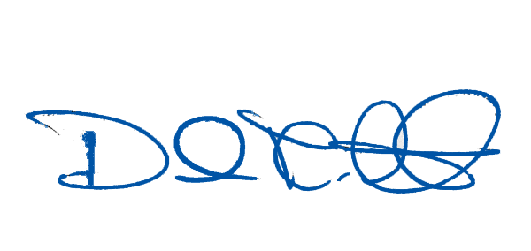
David R. Foster, Director
Cc: Aaron Ellison
Edythe Ellin

